LONGDEN ANNUAL PARISH MEETING 2023
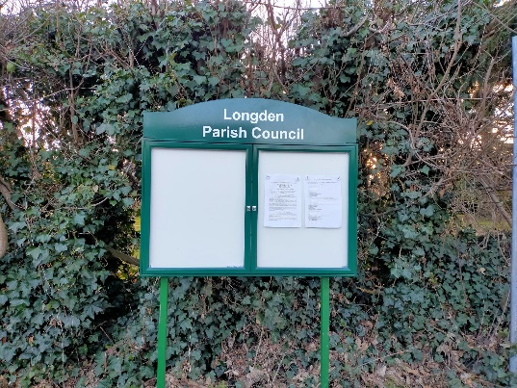  New noticeboard at Lower Common  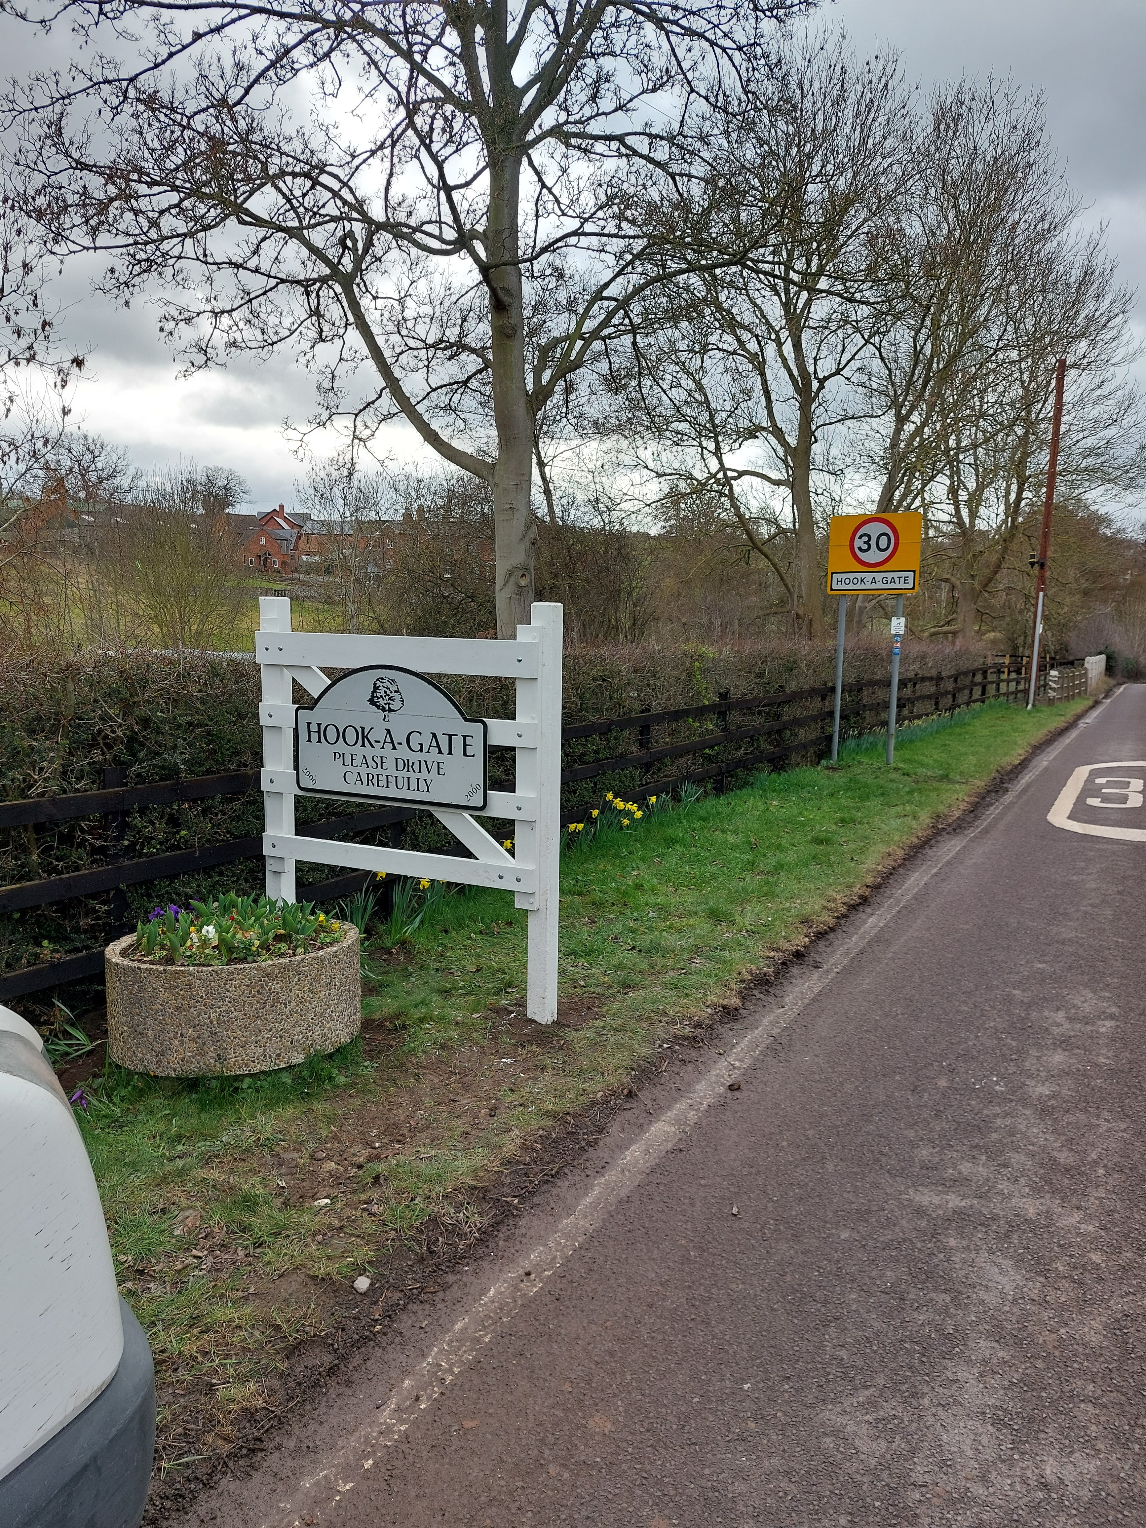  Village gateways at Hook-a-Gate |  | 29th March 2023 – Longden Village Hall 7pm  ​​Residents of Longden Parish (including Annscroft, Hook-A-Gate, Longden, Longden Common, Lower Common, Exford Green, Lyth Bank and The Oaks) are warmly invited to attend the Annual Parish Meeting​.  - ​​Police presentation on speeding and security and a chance to claim a FREE SmartWater marking kit if you have not already received one for your property  - ​Neighbourhood Planning presentation and opportunity to join a steering group to create a Neighbourhood Plan for Longden Parish  - ​Meet your Parish Councillors and find out what they do;  - Open Forum to discuss any matters of interest to the residents  - ​Refreshments available

Paul Carter,
Chair of Longden Parish Council 3 March 2023

