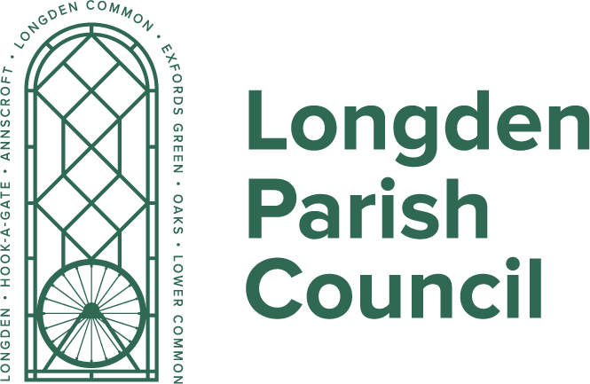
Tel 07759490113 Caroline Higgins
E-Mail: Clerk@longdenparishcouncil.gov.uk Clerk & RFO

Meeting Dates 2026 - 27
Notice is hereby given that full council meetings will be held at The Douglas Swire Memorial Hall, Longden, from 7:30pm on:
Wednesday 3rd June 2026
Wednesday 1st July 2026
Wednesday 2nd September 2026
Wednesday 7th October 2026
Wednesday 4th November 2026
Wednesday 2nd December 2026
Wednesday 6th January 2027
Wednesday 3rd February 2027
Wednesday 3rd March 2027
Wednesday 7th April 2027
Wednesday 5th May 2027 (Annual Council Meeting)
Planning Committee meetings may be called when required and a Finance Committee meeting will be arranged in November to consider the budget.
These will be notified separately and, on the Website, https://www.longdenparishcouncil.gov.uk
Members of the public are warmly invited to attend and may speak in the public participation session held at the beginning of each meeting.

